This template has been aligned with the helpsheet prepared by the Consultative Committee of Accountancy Bodies - Ireland (CCAB-I) and the Irish Banking Federation. It is designed to facilitate the use of a common approach, framework and language in the preparation of business plans and raising of bank finance.

See http://www.ibf.ie/Libraries/Guides_Forms/CCABI_IBF_Business_Plan_Guidance_ 2012.sflb.ashx for further details. Reference has also been made to the Mazars Business Plan Template. See http://www.smallbusinessfinance.ie/tools-and-downloads for further details.

Please note that the template is designed to provide guidance only. No responsibility for loss occasioned to any person acting, or refraining from action, as a result of the material in this publication can be accepted by Fáilte Ireland, CCAB-I or the Irish Banking Federation.

A template to help you with the preparation of a business plan and raising of bank finance
Start-up Business Plan

Start-up Business Plan for Year:

The template is set out with essential and desirable elements for completion.

- It is recommended that these essential elements are fully completed and form the core of the business plan.

- It is recommended that these desirable elements are completed, as necessary, to provide the plan’s readers with sufficient information to form an opinion on the business. This is important where the business is in start-up phase and seeking funding. In all cases where funding is sought, the plan should be compiled with the assistance and direction of an accountant who will provide the necessary guidance on the level of detail required.

Table of Contents:
1. Executive summary
2. Name of business and contact details
3. Business owners and/or directors
4. The business
5. Products, services, customers and marketing
6. Staff details
7. Legal status
8. Names of advisers
9. Suppliers
10. Business assets
11. Business risks and response to risks
12. The project
13. Request for finance
14. Financial information
Summary of Projections
Business Plan Glossary of Terms
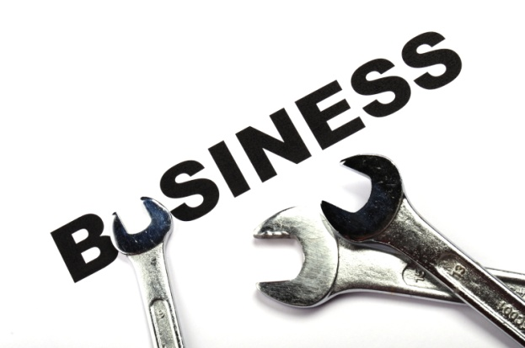

Executive Summary
Write your executive summary after you have completed Sections 2 to 14 of this business plan. Your executive summary should include summaries of the following:

- Purpose of the plan
- Market opportunity
- Management team
- Track record, if any
- Financial projections
- Funding requirements

Write 1 to 3 sentences about each of the above topics. Then finish with a closing sentence or two that answers the question “Why is this a winning business?”

Your Executive Summary should be no more than 2 pages long.

Remember! Tailor your Executive Summary for your target reader. If the purpose of your business plan is to attract investors, your summary should focus on the attractive opportunity your business provides to investors.

Name of Business and Contact Details

Provide information about your business and main contact details.

Business name
Legal form of ownership
Business address
Telephone
Business website
Main contact name (Promoter)
Main contact telephone and email address

Business Owners and/or Directors

Background

Provide the name(s) and background information about the owners and/or directors of the business

Qualifications

Provide information on the owners’/directors’ qualifications, experience and skills.

Experience
Provide information on the owner’s knowledge and experience of the industry and work to date on sourcing key suppliers and staff.

The Business
- Our business
Provide a brief description of the business: type of business (nature of business/sector operating in, the business concept) description of property, access, proximity to customers/competitors/ amenities, etc.

- Our operations
Describe how the business will operate and include:
- opening hours, seasonality, etc.
- facilities and resources available to the business
- management of quality and service standards
- plans for Health and Safety plans for Environmental and Waste Management

- Key trends in the sector
Describe how the sector is structured:
- large or small businesses,
- many or few players,
- over/under supply of the type of products/services you propose to offer?
- overall growth projections for the sector in your region
- supports available for businesses such as yours and how you will maximise your usage of those supports
- the main trade associations and your involvement with them

- Our vision for the future of the business

Briefly describe what you ultimately want to achieve in your business.

- Our mission for the business
Describe what type of business you will operate as you work towards that vision and outline what you will do for key stakeholders.

- Our goals and overall strategy for the business
Itemise the short and long term, measurable goals you are trying to achieve in areas like sales, profit, customer satisfaction, employee satisfaction, etc. Describe how you will achieve the defined profitability or return on investment target.

Products and Services, Customers and Marketing
Products and Services

- Features of our products and services
Describe the features of the products and services offered: the characteristics and uniqueness of your planned products/services.

- Uniqueness of our products and services
Explain how you will promote and sell the uniqueness of your products and/or services in your sales and marketing messages to distinguish them from your competition (include reference to telephone, face-to-face conversation, websites and print communications, as appropriate).

- Benefits of our products and services
Describe the benefits of the products and services offered: what the customer has to gain by buying your products/services (e.g. wellbeing, convenience).

Customers

- Our key targeted customer types
Provide information on your key targeted customers. Examples include families, tour groups, corporate clients and special interest markets, whether from domestic or overseas markets or both.

- Our key targeted customer characteristics
Provide further information on your key targeted customers in terms of their characteristics, their geographic locations, what their buying behaviour is and the proportion of sales to each customer type.

Marketing

- Our main marketing activities
Provide a description of the main marketing activities planned showing how the potential of the business will be translated into sales. Marketing activities may include promotions, advertising and special offers.

- Trends in the markets we will operate in
Summarise the trends in the market(s) you will be operating in, including its size and potential.

- Research on the markets we will operate in
Provide details on the research carried out in the market(s) you will be operating in.

- Our pricing strategy
Describe your pricing strategy in terms of the importance (or otherwise) of pricing as a competitive advantage, together with the approaches you will adopt when setting prices (mark-up, margin based, value based) and outline your credit/payment terms.

- Our distribution strategy
Describe the main distribution channels associated with your offering (direct to consumer, via travel agents and/or tour operators) and how you will use those channels to sell your offering to Irish and overseas customers.

- How we will promote our products and services
Summarise your promotions strategy, the channels you will use to reach your target market: this will likely include engaging in sales, public relations and e-marketing activities:
- Sales activities include direct selling and visiting clients
- Public relations activities are conducted through the media, e.g. newspapers, television and magazines
- E-marketing activities include Facebook campaign and ezine
- Maximising the use of website features
- Maximising the use of non-paid advertising, e.g. trade shows, word of mouth (how will you stimulate it?), network of friends or professionals
- Maximising the use of other promotional supports, e.g. logo design, cards and letterhead, brochures, signage, etc.
- Complimentary business opportunities, for example, a B&B business operation could collaborate with a walking tours business operation to provide an accommodation/walking tours package

- How we will manage our marketing spend
Provide a forecast and roll out of the expected marketing spend for the first three years in line with your sales projections.

Staff Details
- Our management team
Provide the required qualifications and experience of your projected key people and the key functions to which they will be assigned (e.g. operations, finance, HR, sales, etc.).

- Our employees
Give the projected number of employees by function (administration, sales, operations, etc.) and by status (full- and part-time), their expected skills and experience, together with planned recruitment and training initiatives.

- How we will plan our staffing requirements
Provide a staffing plan of the roles to be filled, and when (bearing in mind expansion of the business), together with relevant costs of filling these roles. Describe how you will attract and recruit staff and provisions for relevant training.

Legal Status
- The legal structure of the business
Describe the legal structure of the business (sole trader, partnership or limited company) and, if appropriate, an explanation on why you chose that particular legal format. Provide the names and holdings of the shareholders as well as the directors where the structure is a limited company.

- The legislative aspects of the business
Provide details of the legislations and regulations that apply to the operating of the business (planning requirements, licences, registration, compliance with tax legislation, etc.).

Names of Advisors
- Name of Accountant
Provide the name of the Accountant you have secured.

- Names of other professionals
Provide the names other professionals advising you (solicitors, architects, consulting engineers, etc.), together with details of government/local support agencies.

- Names of strategic partners
Provide the names of strategic partners and their roles where these are key to the business.

Suppliers
- Key suppliers
Provide the names of your key suppliers to be used, the products/services provided by them and the reasons for choosing them (as opposed to alternative suppliers). Give details of contracts and terms (payment, delivery, quality, quantity, etc.) already agreed or to be agreed.

Business Assets
- Premises
Provide information on the business – its location, the property (and title) and its carrying value (where rented, provide details of terms, amount of rent payable, frequency of payment, leased term, years remaining, rent review periods).

- Equipment
Provide information on the current and proposed equipment needed (including vehicles, furniture and fittings), together with details on costs, funding, current value and when it will be fully owned / paid off.

Business Risks and Response to Risks
- Key risks affecting the business
List the key risks affecting the business and how you propose to respond to them.

- Our key competitors and what they offer
List the key competitors (search beyond your local area) and what they are doing to attract customers to their products and services.

- Our competitors' strengths and weaknesses and what we will do to address them
Describe the ways in which your competitors are successful and areas where they weak, in terms of product offering, price, service, quality, promotions, etc. and the approaches you will take to respond to competitive pressures. Describe what you will do to consolidate your markets, develop and retain a loyal customer base and how you will continuously innovate to stay ahead of your competitors.

- Our strengths and what we will do to maximise them
Describe your strengths (issues under your control that will make your business successful and provide a competitive advantage). Examples of business strengths include unique product, access to finance, contacts, experienced and skilled workforce.

- Our weaknesses and what we will do to address them
Describe your weaknesses (issues under your control that will prevent you from doing better business). Examples of business weaknesses include lack of financial expertise or poor knowledge of marketing.

- External opportunities and how we will exploit them
Provide an overview of the external opportunities (issues outside your direct control that can be of benefit to your business). Examples of external opportunities include changes in customer spending patterns and new e-marketing methods.

- External threats and what we will you do to address them
Provide an overview of the external threats (issues outside your direct control that have negative consequences for your business). Examples of external threats include the arrival of strong new competitors, worsening economic conditions, escalating costs and increased regulation.

- Other risks and what we will you do to address them
Identify other potential risks that the business may face (e.g. exposure to foreign exchange or interest rate fluctuations) and describe what you will do to minimise the impact of these risks (e.g. insurance cover if appropriate).

The Project

- Key milestones
Outline the key milestones of the business, with particular emphasis on the stages of development. This could include construction timelines, kit-out, staged opening and further development plans. Include your break even timeline here. Refer to headings 5 to 11 where this is a new project within an existing business.

Request for Finance

- Financial requirement
Provide details of the amount and timing of finance requested, together with a proposed repayment schedule.

- Uses of finance
Provide a detailed description of how funds will be spent and, in the case of loans and other credit, how and when repayment will be funded.

- Sources of finance
Outline any other sources of finance being requested or approved such as investment by the promoter, grant aid, etc. that will supplement the credit finance being sought.

Financial Information
- Current financing arrangements
Provide information on the current financing arrangements:
- Names of current lenders
- Amounts and terms of loans
- Maturity of loans
- Covenants
- Security and guarantees
- Internally generated capital including directors’ loans, and terms attaching to these, shareholdings and reserves
- Other sources

- Projected financial statements
Provide projected financial statements for an appropriate number of years:
- Profit and loss accounts
- Balance sheets
- Cash flow statements, indicating peak borrowing requirements

- Key assumptions
Outline the key assumptions made by you in relation to the financial information.

- Gross profit margin
Show the gross profit margin you expect for each key product/service. The Gross Profit Margin is the percentage profit a business makes on a sale. Gross profit is sales revenue less the cost of sales.

- Credit policy
Outline your credit policy relating to Debtors and Creditors.

- Major expenses
List your major expenses such as payroll, rent, raw materials etc.

- Scenario analysis
Carry out a scenario analysis on the projected financial statements to demonstrate key variations of assumptions, such as variations of sales figures by factors such as 10% or 20%, or variations caused by risk factors identified above.

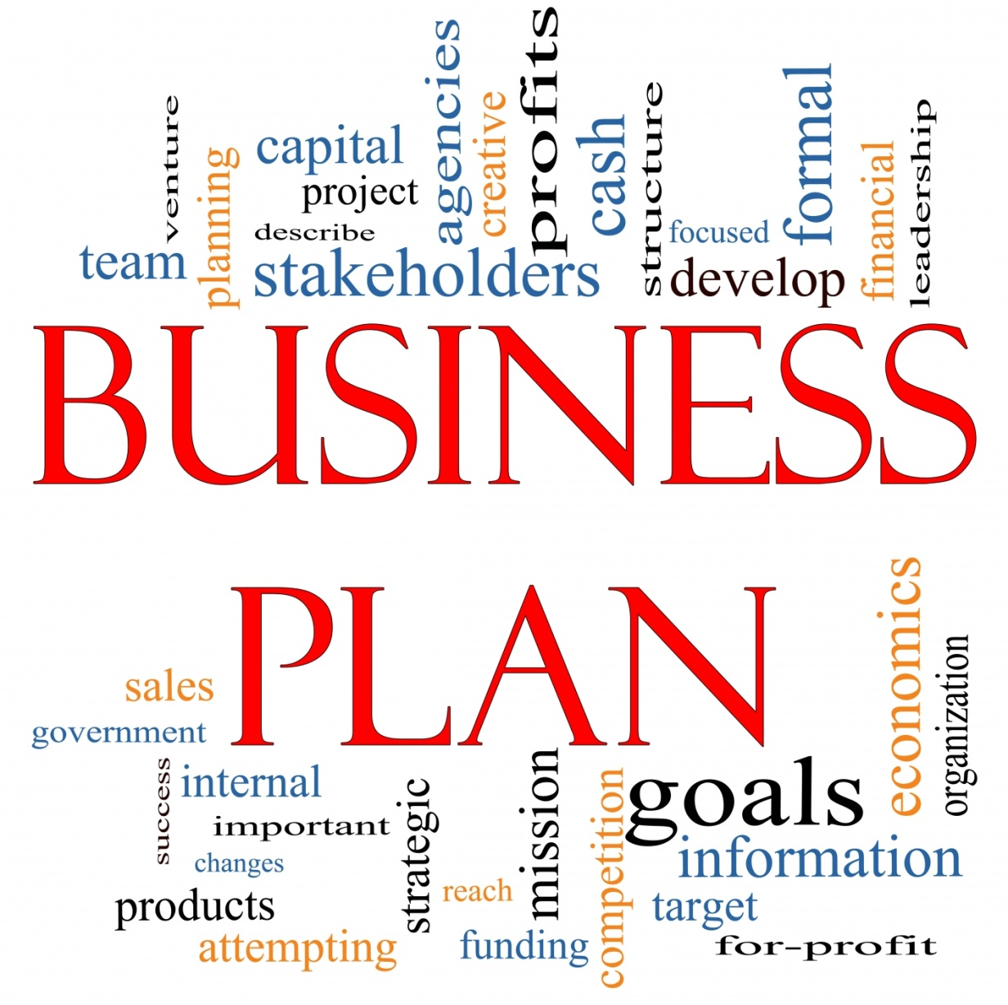

Summary of Projections

Profit & Loss | Year 1 | Year 2 |  | Cash flow | Year 1 | Year 2
 | €'000 | €'000 |  |  | €'000 | €'000
Sales |  |  |  | Opening balance
Cost of Sales
Gross Profit |  |  |  | Inflows
Overheads
EBITDA |  |  |  | Outflows
Depreciation
Interest / Charges
Taxation
Net profit/(loss) |  |  |  | Closing Balance
Balance Sheet | Year 1 | Year 2 |  | Ratios | Year 1 | Year 2
 | €'000 | €'000
Fixed Assets |  |  |  | Current Ratio
 |  |  |  | Quick Ratio
Current Assets |  |  |  | Working Capital: Sales Revenue | % | %
Current Liabilities |  |  |  | Debtors : Creditors Ratio
Net Current Assets |  |  |  | As a ratio of Sales:
Long-term Liabilities |  |  |  | EBITDA | % | %
 |  |  |  | EBIT | % | %
 |  |  |  | Profit before tax | % | %
Net Assets |  |  |  | PAT | % | %

Business Plan Glossary of Terms

Activity (Key): anything undertaken within a business which is deemed important to achieving its aims and objectives.
Amortisation: preferred term for the apportionment (charging or writing off) of the cost of an intangible asset as an operational cost over the asset's estimated useful life. It is identical to depreciation, the preferred term for tangible assets.
Annual Report: a document which summarises business performance and achievements over a stated year, including key financial reports.
Benchmarking: the act of externally comparing a business’ results (performance benchmarking) with accepted norms; it may also entail comparing a key business activity (process benchmarking) with other entities which are deemed to deliver best practice in that area.
Benefit: desirable attribute of a product or service, which a customer perceives he or she will get from purchasing.
Business Plan: a detailed document (usually short or medium-term focused) which is developed to guide business activities and to outline the actions to be taken over the period in order to implement strategies to achieve the strategic goals and objectives. Financial projections are also included.
Business Planning: the structured activity of undertaking the necessary research and analysis in order to define the direction for the business, usually culminating in the development of a strategic or business plan.
Challenges: key internal and external issues, problems and opportunities facing the company at any given time.
Credit Policy: clear, written guidelines that set (1) the terms and conditions for supplying goods on credit, (2) customer qualification criteria, (3) procedure for making collections, and (4) steps to be taken in case of customer failure to pay.
Current Asset: an asset such as receivables, inventory, work in process, or cash, that is constantly flowing in and out of an organisation in the normal course of its business, as cash is converted into goods and then back into cash. In accounting, any asset expected to last or be in use for less than one year is considered a current asset.
Current Liabilities: obligations such as trade credit and unpaid taxes arising in the normal course of a business and due for payment within a year.
Current Ratio: indicator of a company’s ability to meet short-term financial obligations, it is the ratio of current assets to current liabilities. Formula: Current assets ÷ Current liabilities.
Depreciation: the gradual conversion of the cost of a tangible capital asset or fixed asset into an operational expense (called depreciation expense) over the asset's estimated useful life.
Distribution Strategy: a plan that specifies how the business intends to make customers aware of its products and services.
EBITDA: computed by subtracting cost of sales and operating expenses (but not amortisation and/or depreciation, interest, and taxes) from total revenue.
Executive Summary: section of the business plan that should be completed after the business plan is written. It highlights all milestones in the company’s development over the next three years.
Financial Statement: summary report that shows how a business has used or will use (projected) the funds entrusted to it by its shareholders and lenders, and what is its current financial position. The three basic financial statements are the (1) profit & loss account, which shows how the net income of the business is arrived at over a stated period, (2) balance sheet, which shows the business’ assets, liabilities, and net worth on a stated date and (3) cash flow statement, which shows the inflows and outflows of cash caused by the business’ activities during a stated period.
Fixed Asset: an asset that is not consumed or sold during the normal course of business, such as land, buildings, equipment, machinery, vehicles, leasehold improvements, and other such items. Fixed assets enable their owner to carry on its operations.
Goal: an observable and measurable end result having one or more objectives to be achieved within a more or less fixed timeframe.
Gross Profit Margin: a measure of a company's profitability that is expressed as a percentage of gross profit. It is calculated by dividing gross profit by revenue.
Indicator (Key Performance): a strategically important measure used to monitor business performance; may be both financial and non-financial in nature.
Milestone: an indicator of progress denoting an achievement to date.
Mission: a statement of intent by a business as to how it will conduct its operations with regard to key stakeholders such as investors, customers and employees.
Objective: an end that can be reasonably achieved within an expected timeframe and with available resources. In general, an objective is broader in scope than a goal, and may consist of several individual goals.
Opening Balance: balance brought forward at the beginning of a new accounting period, on the credit or the debit side of the ledger.
Parameters: the constraints within which specific actions must be taken or decisions must be made.
PEST Analysis: a planning tool used to help identify the future Political, Economic, Social and Technological influences on a business.
Policy: a general statement outlining a course of action to be taken in order to achieve a defined objective (s).
Product Features: a function of a product which is capable of satisfying a particular consumer need and is seen as a benefit of availing of the product/service. In business, a product feature is one of the distinguishing characteristics of a product or service that helps boost its appeal to potential buyers, and might be used to formulate a product marketing strategy that highlights the usefulness of the product to targeted potential consumers.
Quick Ratio: an indicator of a company's short-term liquidity. The quick ratio measures a company's ability to meet its short-term obligations with its most liquid assets. The higher the quick ratio, the better the position of the company. The quick ratio is calculated as: Current Assets – Inventories divided by Current Liabilities. Also known as the "acid-test ratio".
Risk: the probability that an actual return on an investment will be lower than the expected return.
Scenario Analysis: scenarios are used in estimating the probable effects of one or more variables on the business plan.
Stakeholder: any group or individual with an interest in, or an influence on the operation of a particular business.
Standard: a statement of the specific outcome required following the completion of a particular task.
Strategic Plan: a master plan for a business which defines its vision and mission, strategic goals and the general strategies to be followed to achieve those goals.
Strategy: a specific set of longer-term actions which are designed to achieve the aims and objectives of a business.
SWOT analysis: a planning tool for considering the internal Strengths, Weaknesses, Opportunities and Threats facing a business.
Target: a defined outcome to be achieved which is measurable, time-limited, and related to a broader aim or objective.
Uniqueness: (USP) real or perceived benefit of a product or service that differentiates it from the competition and gives its buyer a logical reason to prefer it over other products or services.
Vision: a general statement which captures the ideal long term hopes and aspirations for the development and growth of a business.

This guide has been provided to you as part of Fáilte Ireland’s suite of guides and templates in the Online Business Tools resource.
Please note that these resources are designed to provide guidance only. No responsibility for loss occasioned to any person acting, or refraining from action, as a result of the material in this publication can be accepted by Fáilte Ireland.
The user shall not market, resell, distribute, retransmit, publish or otherwise transfer or commercially exploit in any form any of the content of this guide. For a full version of the disclaimer, go to http://www.failteireland.ie/Footer/Legal-Terms.aspx

Fáilte Ireland
88-95 Amiens Street
Dublin 1
Telephone: 1800 24 24 73
CustomerSupport@failteireland.ie
www.failteireland.ie

© Fáilte Ireland 2013
OBT-13STB-SBP T1 11-12 3

