Health & Wellness
Sample Itinerary for Irelands Ancient East & Wild Atlantic Way
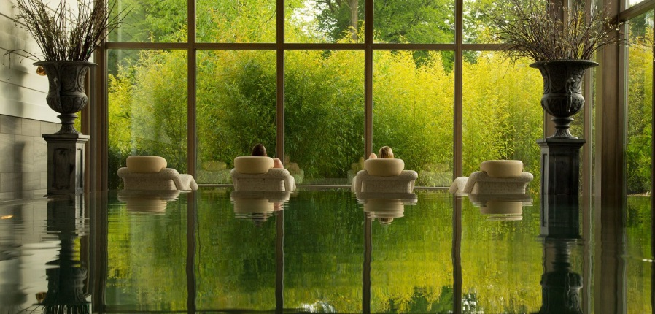
Switch off and get away from it all in Ireland’s Ancient East and the Wild Atlantic Way. Enjoy gentle walks immersed in nature and take an opportunity to discover some of Irelands hidden gems and historic treasures while relaxing in luxurious accommodation in scenic locations each night
Day 1

Morning | Arrive in Dublin Airport and meet your local guide and driver and depart for Wicklow, otherwise knows as ‘’the Garden of Ireland’’.
Lunch/Noon activity |   Brook Lodge & Macreddin Village  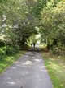  Continue on to County Wicklow to BrookLodge and Macreddin Village, where you can enjoy a ‘’stretch of leg’’ on a beautiful walk/cycle in the woods followed by a sumptuous healthy lunch at the Lodge/ alt healthy packed lunches, also available to the group.  http://www.brooklodge.com/sundry/FreeandLowCostActivities.asp
Late Afternoon | Arrive at Monart Destination Spa, check in and switch off your phone and enjoy a relaxing Spa Treatment before dinner
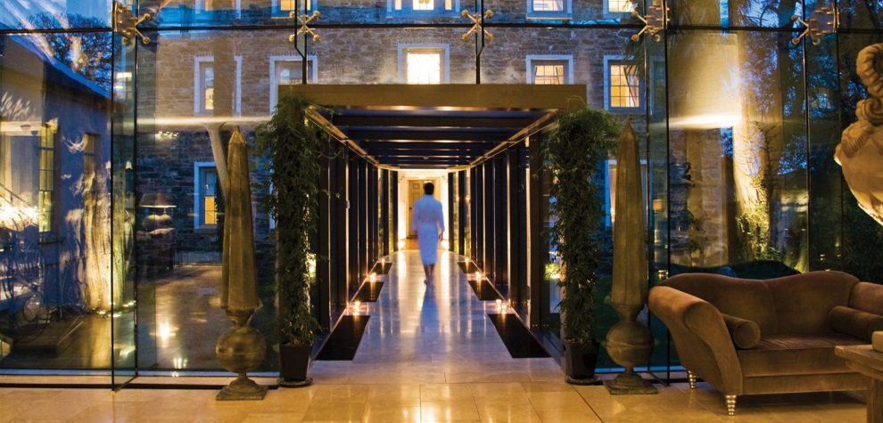
Overnight in Monart Destination Spa, The Still, Enniscorthy, Co Wexford - www.monart.ie
Day 2

Morning |  | 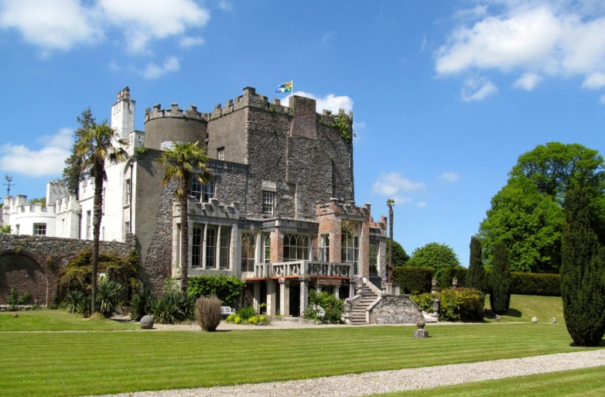  Depart Enniscorthy for Co Carlow and discover one of Ireland’s hidden gems - Huntington Castle - which now comes under Failte Ireland’s new welcome standard accommodation. This fascinating castle is still lived in by the descendants of the original owners. Get a guided tour of the castle and gardens and get to see its Temple of the Goddess - which celebrates the divine feminine - in the unique atmosphere of the basement www.huntingotoncastle.com
Afternoon |  | 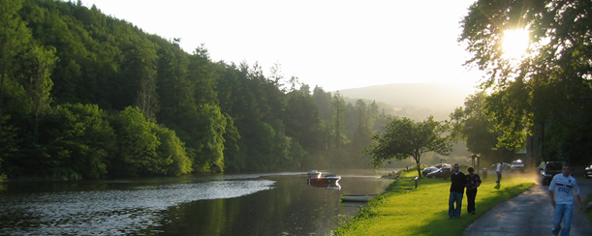  Depart Clonegal for Killedmond and meet Mary White from Blackstairs Eco Trails. After some refreshments, depart for an Eco Trail along the banks of the River Barrow. Have a healthy homemade lunch at the Old Rectory in Borris - this will comprise of local organic ingredients. After lunch depart for a short forage walk and look for edible safe wild food and get to sample some of what you find! www.blackstairsecotrails.ie
Evening |  | 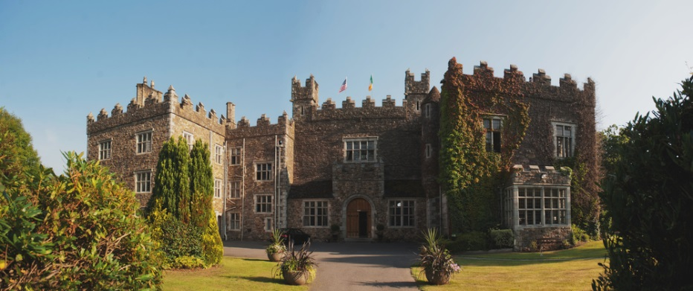  Overnight in Waterford Castle - situated on an island; it was home to the Fitzgerald family for for hundreds of years and was passed down for several generations, however in the 1980, the castle was sold and turned into a luxury hotel set in beautiful natural surroundings. There are few areas in the world today still untouched by modern society, and the grounds which this historical castle is situated is most definitely one of these - http://waterfordcastle.com
 |  | Day 3
 |  | Continue onto Cork.
Morning |  | This morning, experience the wonderfully refreshing Solas Na Mara Seaweed Baths in Dungarvan http://solasnamara.ie/seaweed-baths/ in Waterford and give your skin some vital renewals.
Noon |  | 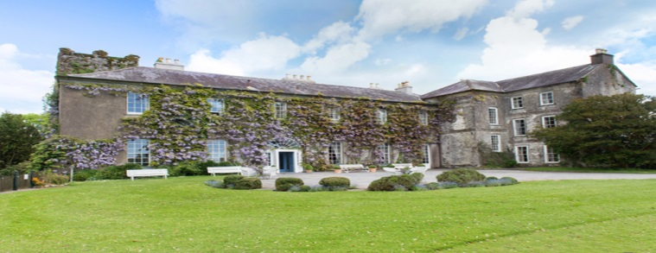  Visit Ballymaloe House and a food for the soul experience in Shanagarry East Cork!  Whilst here you will plant an Oak tree in their wonderful garden grounds, followed by a brief cooking demo of ‘’healthy eating for life’’ all the whislt using fresh local ingredients and food from local area. Enjoy some time in the kitchen garden here and lunch on site.  http://www.ballymaloe.ie/
Afternoon |  | 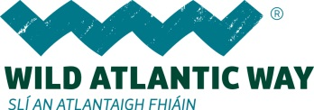  Begin your journey on the Wild Atlantic Way. Make your way to West Cork, to Clonakility to the the secluded Inchydoney Hotel Resort.  Enjoy an afternoon session of Yoga on the beach here at this wonderfully located beach resort.  http://www.inchydoneyisland.com/  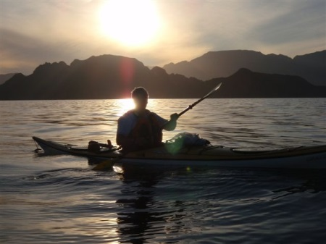  This evening be moved by the stillness and natural beauty around you and enjoy a private guided sunset sea kayaking trip from the resort with Jim Kennedy of Atlantic Sea Kayaking.  http://www.atlanticseakayaking.com/west-cork-moonlight-night-time-trip.html
Evening |  | Overnight and dine at Inchydoney Lode & Spa, West Cork  http://www.inchydoneyisland.com/
 |  | Day 4
Morning and afternoon |  | 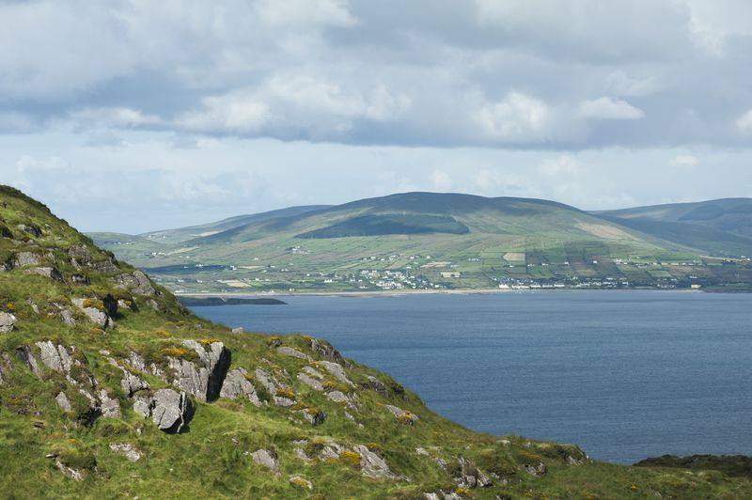  A day of mediatation and reflection in Beara Peninsula, West Cork  At the Dzogghen Beara, every session is suitable for beginners and is guided by an experienced instructor. You can sit on a chair or on a cushion on the floor, wherever you are comfortable and there are no difficult postures or complicated techniques.  More and more people are discovering the benefits of meditation. This ancient method has come to be seen as a powerful support for modern life—something that can be practised anywhere, by anyone, of any age or background. Enjoy the wonderful views of the wild Atlantic Way and the Beara Peninsula from their mediataion rooms, both of which have floor to ceiling windows with spectacular ocean views.  Lunch healthy option on site today at the centre.  https://www.dzogchenbeara.org/
Late Afternoon |  | .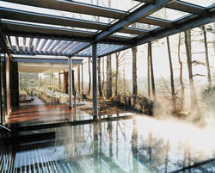  Continue over the scenic Healy Pass and onto your hotel, for afternoon tea, The Kenmare Park Hotel, in the picturesque heritage town of Kenmare, Co Whilst here be sure to relax and take time at the award winning Sámas Spa in the Park Hotel Kenmre this afternoon.  http://www.parkkenmare.com/  Dinner this evening in one of the wonderful restaurants the area has to offer, like Packie’s or The Lime Tree, offering the best of local produce and cuisine.  Enjoy Irish music for the soul, in a local pub later this evening!
 |  | Day 5
Morning/late afternoon |  | 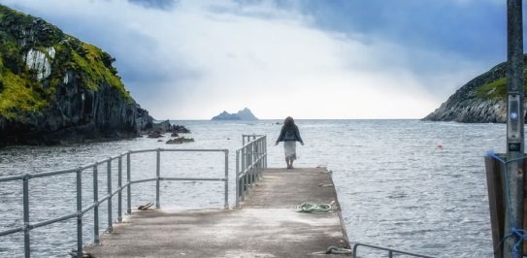  Drive around the scenic Ring of Kerry this morning taking in the scenery and sounds of this naural gift of Mother Nature.  Enjoy a walk along Derrynane Mass Loop this morning  13km (8 miles); 3-5 hours  Rough tracks and roadway; Loop Comfortable walking shoes or trainers. This is an interesting, beautiful and varied loop walk in the Derrynane area, incorporating forest, farmland, beach and quiet country roads. Stunning views and historical sights abound.  Refreshments at Derrynane House, home of the Home of ‘The Liberator’, Daniel O’Connell, Derrynane (Doire Fhionain, St. Finian’s Oakwood) still inspires feelings of hope and freedom.  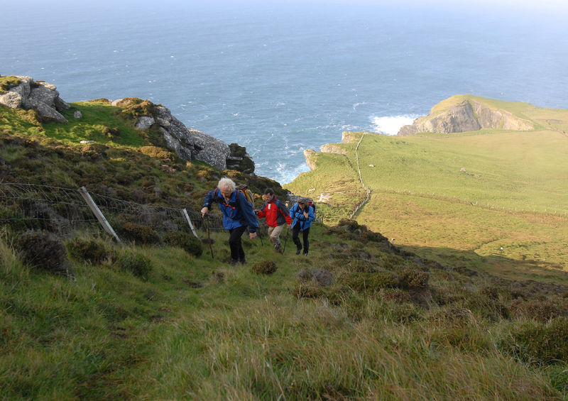  Continue on to explore Skellig Ring with views out onto World Heritage UNESCO site Skellig Michael*.  *Depending on time of year and weather conditions boat tours are available also to land/then climb onto this rugged location and could be an alt. to the Deerynane Mass Loop.  Stay in an authentic castle surrounds this evening at Ballyseedy Castle Hotel in Tralee, close to this evenings entertainment options and ideal for smaller groups : http://www.ballyseedecastle.com/  This evening enjoy an early dinner at a local restaurant like Cassidys or Finnegans Wine Cellar in Tralee, followed by an authentic Irish folk musics and dance perfromance at Siamsa Tire, Irelands National Folk Theatre http://www.siamsatire.com/
 |  | Day 6
Morning |  | Continue on to Shannon and Clare area travelling along the Wild Atlantic Way. Take Car/Coach ferry from Tarbert to Kilimer, crossing the mouth of River Shannon.  Make your way to the Burren, The Burren region is internationally famous for its landscape and flora, peace and tranquillity. A visitor can enjoy the colourful diversity of flowering plants living together within the one ecosystem.  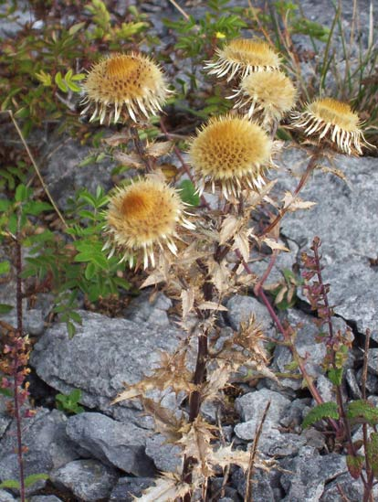  Arctic-alpine plants living side by side with Mediterranean plants, calcicole (lime loving) and calcifuge (acid loving) plants growing adjacent to one another and woodland plants growing out in the open with not a tree nearby to provide shade from the sun. Also found here are certain species which although rare elsewhere are abundant in the Burren. Even more amazingly they all survive in a land that appears to be composed entirely of rock
Late morning |  | Today you have a choice of these activities in this area: You can enjoy either a session of Burren yoga www.burrenyoga.com or a personalised guided walk and talk on the Burren today http://www.clare.ie/do/burren-experience-guided-walks/ .  Lunch included at both activities.  Continue on to Galway, City of Tribes to overnight. Enjoy time to meander around the bustlingstreet in this coulorful recently awarded European City of Culture host 2020.  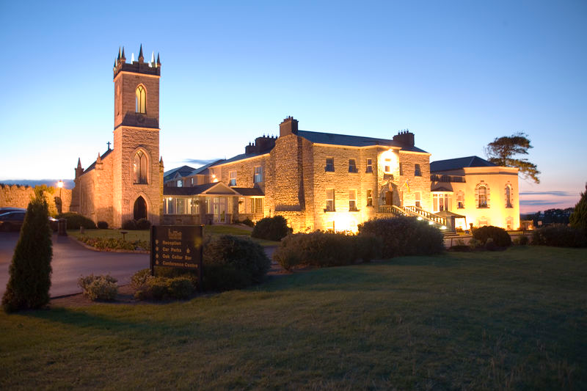  Overnight and dine with light music entertainment at Pullman Restautant at the 5* Glenlo Abbey Hotel , located by Lough Corrib http://www.glenloabbeyhotel.ie/en/5-star-hotel-galway/
Day 7

Transfer and depart from Dublin/Shannon airports – all within 2-3 hours of Galway city.

