Spiritual Group Itinerary

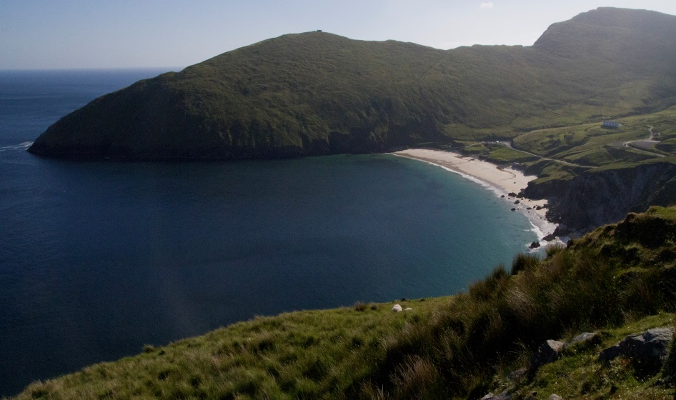

Sample Itinerary for Wild Atlantic Way

Discover the raw, rugged beauty of the Wild Atlantic Way and walk in the footsteps of some of Ireland’s greatest saints. Home to monastic settlements, holy mountains and ancient centres of learning, the Wild Atlantic Way is the world’s longest defined coastal touring route. Spanning some 1,500 miles along Ireland’s western seaboard it is home to Ireland’s Irish language communities in the Gaeltacht regions, the highest sea cliffs in Europe and 26 off shore islands including Inishmurray, with its remarkably preserved 6th century monastic settlement.

Arrive Shannon or Dublin Airports and meet your local guide and driver.
Depart for Galway (journey time 2hrs30mins both ways).

Overnight Galway city.
 | Day 1
AM  PM  AM  PM | Depart for Connemara and Kylemore Abbey & Victorian Walled Garden.  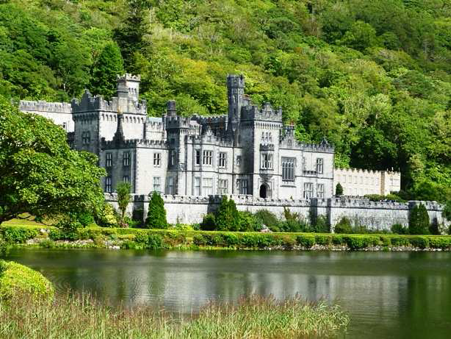  Kylemore Abbey & Victorian Walled Garden is home to a community of nuns of the Benedictine Order who came here in 1920 after their abbey in Ypres, Belgium was destroyed in World War I. Settling at Kylemore, the Benedictine Community opened a world renowned boarding school for girls and began restoring the Abbey, Gothic Church and Victorian Walled Garden to their former glory. Just a five minute walk along the shores of Lough Pollacapull lies Kylemore’s enchanting neo-Gothic Church. Described as a ‘Cathederal in Miniature’ this elegant building is a lasting testament to the love of Mitchell Henry for his wife Margaret. Regular musical performances take place here throughout the year.  www.kylemoreabbey.com  Lunch Kylemore Abbey.  Continue to Croagh Patrick, considered to be the holiest mountain in Ireland.  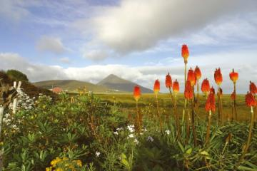  St Patrick’s sacred mountain ‘Croagh Patrick’ is situated 5 miles from Westport and the mountain’s conical shape soars majestically above the surrounding countryside. Each year The Reek (as it is known by the locals) attracts pilgrims from all over the world. Climb up the rock path to the summit.  www.croagh-patrick.com  Overnight Croagh Patrick Holiday Village www.croaghpatrickholidayvillage.ie  DAY 2  Depart for the coastal village of Strandhill, Co Sligo and Voya Seaweed Baths.  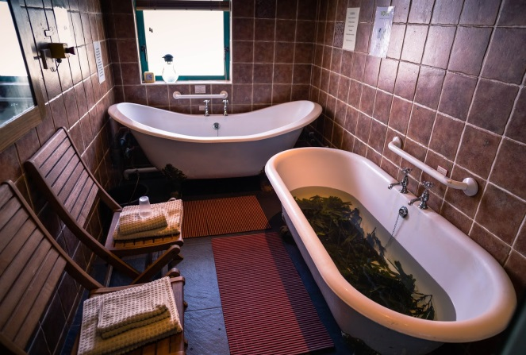  Indulge your senses and enjoy the detoxifying benefits of a natural seaweed bath at Voya Seaweed Baths.  www.voyaseaweedbaths.com  Lunch in The Strand Bar. The challenging swells ensure it is a mecca for the surfing fraternity the world over and the sight of a surfer catching a wave is a regular occurrence.  www.thestrandbar.ie  Head for Mullaghmore and take the boat to Inishmurray Island, 7km off the coast of Sligo.  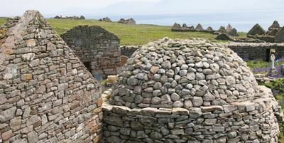  Explore the Monastic Settlement at Inishmurray Island with its beehive huts where the monks of this remarkable 6th century Christian site once lived. The stones of the large altar known as the Clocha Breacha – the ‘Cursing’ or ‘Speckled Stones’ are said to have dark powers. The last islanders moved to the mainland in 1957 and the island is now a wildlife sanctuary for both breeding and wintering birds.  www.inishmurrayislandtrips.com  Return to mainland and continue to Rossnowlagh, Co Donegal.  Overnight La Verna Retreat Centre, www.lavernarereat.com
Morning | DAY 3  La Verna Retreat Centre  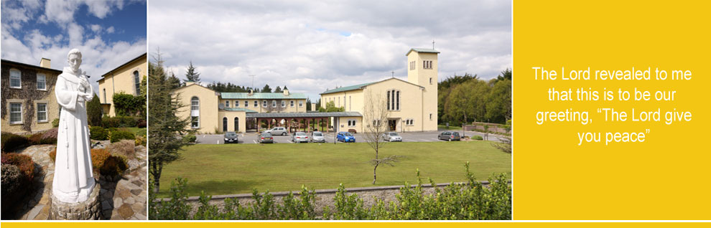  Imagine a Retreat Centre nestling in woods next to a Franciscan Friary, surrounded by beautiful gardens, with an exquisitely beautiful chapel in its midst and overlooking a coastal landscape. According to their guests, this place of peace and tranquility provides a space away from the demands of life and an opportunity to rest and relax in a beautiful setting by the Atlantic sea. La Verna offers excellent modern facilities with a range of Day or Residential Retreats and Workshops, Private Stays and Group Bookings throughout the year that are excellent value for money for everyone.  Dinner this evening at local restaurant, with some wonderful sea views, the Smugglers Creek, Rossnowlagh. http://smugglerscreekinn.com/  Overnight La Verna Retreat Centre
 | Day 4
Morning & Afternoon | Continue on today and walk in the footsteps of one of Irelands Great Saints St. Colmcille. With a local guide enjoy a guided walk and talk along some of the trail in Gleann Cholm Cille.  Slí Colmcille (the St Columba Trail) is a trail in the footsteps of the early Irish saints from south-west Donegal to Iona and the Isle of Lewis in Scotland. St Colmcille, or Columba, was one of the greatest of all early Irish saints. He left Ireland as a monk in 564 for Scotland, where he founded the monastery of Iona. His churches shaped both Ireland and Scotland.  The trail can be seen online at www.colmcille.org. For early monks, this was a ‘Sea road of the Saints’, travelled in frail boats. In Donegal, the route is shared with The Wild Atlantic Way. While the trail is suitable for car and  ferry, in Donegal and elsewhere, many areas are ideal for walking and cycling.  Slí Cholmcille starts in south-west Donegal in Gleann Cholm Cille, which nestles behind Sliabh Liag, which has the highest sea cliffs in Europe, and is a signature point for the Wild Atlantic Way.  In Gleann Cholm Cille, the Slí Cholmcille follows the route of the Turas Cholmcille. The turas - translated as the journey - is part of a strong Christian pilgrimage tradition in Ireland.  The Turas links a number of ancient stones some of which date back to 3000BC. The standing stones which form the core of the Turas probably date from 500-700AD.  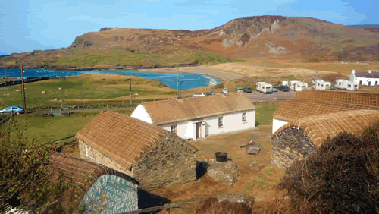  A visit and lunch stop whilst here is at The Folk Village Museum,  a cluster of several small cottages, called a ‘clachan’, perched on a hillside overlooking the sandy curve of Glen Bay Beach in the Gaeltacht (Irish-speaking area) of South West Donegal. Designed, built and maintained by the local people, the Folk Village is one of Ireland's best living-history museums.  Take a look at how our ancestors lived, cooked, the beds they lay on, the tools they used, their means of lighting and heat. Learn how they developed rich traditions in music, dance and crafts despite the material hardships of daily life.  Time for reflection later this afternoon at The Friary, Rossnowlagh, a place of hospitality and welcome for all who seek peace and reconciliation. They welcome people to prayer and table. The Friars serve in church ministry, give retreats and workshops, offer counselling and spiritual direction as well as simply being available to anyone who calls to the Friary. http://www.franciscans.ie/rossnowlagh/
Evening | 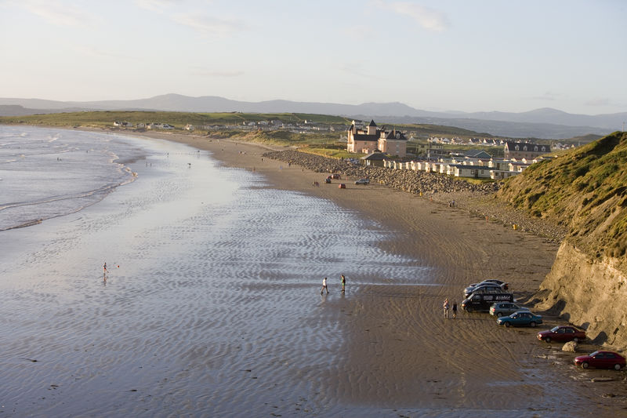  Dinner and traditional Irish music entertainment this evening at beach located, The Sandhouse, Rossnowlagh. http://www.sandhouse.ie/  Overnight La Verna Retreat Centre.
 | Day 5
Morning | Time for some early morning reflection at La Verna Retreat Centre.  Your journey takes you homeward today.  Allow 3 hours commute from Donegal to Dublin Airport &  3hrs 40mins to Shannon Airport.

